GHANA COMMUNICATION TECHNOLOGY UNIVERSITY

FACULTY OF COMPUTING AND INFORMATION SYSTEMS
DEPARTMENT OF INFORMATION TECHNOLOGY
INTERNET TECHNOLOGIES & WEB DESIGN
BY
AKANKOBATENG RUEBEN ANSOLIWEN
1703109906
BSc INFORMATION TECHNOLOGY
LECTURER DR. WILLIAM BROWN-ACQUAYE
LEVEL 300 GROUP B
30th DECEMBER 2025

Chapter 1: Introduction
1.1 Project Background
In today's competitive technology industry, having a strong online presence is essential for iOS developers seeking to showcase their skills and attract potential employers or clients. A portfolio website serves as a digital resume, providing a comprehensive view of a developer's capabilities, projects, and professional experience. This project involves the creation of a professional portfolio website specifically designed for an iOS developer, built entirely using hand-coded HTML, CSS, and JavaScript without relying on WYSIWYG web authoring tools.
The portfolio website aims to present a clean, modern interface that reflects the aesthetic principles associated with Apple's iOS platform. By creating this website, I demonstrate not only my iOS development skills but also my understanding of web technologies and my ability to create engaging user experiences across multiple platforms.
1.2 Project Objectives
The primary objectives of this website development project are as follows:
First, to create a functional and visually appealing portfolio website consisting of at least five interconnected pages that showcase my skills and projects as an iOS developer. Second, to demonstrate proficiency in core web technologies including HTML5, CSS3, and JavaScript through hand-coded implementation. Third, to establish an online presence that can be accessed by potential employers, clients, and collaborators in the technology industry. Fourth, to apply principles of user experience design and responsive web development to create an accessible and user-friendly website. Finally, to successfully deploy the website on a live web hosting platform, making it publicly accessible via the internet.
As shown in Figure 1.1, the site map illustrates the overall structure of the portfolio website, with the home page serving as the central navigation hub connecting to four additional pages.
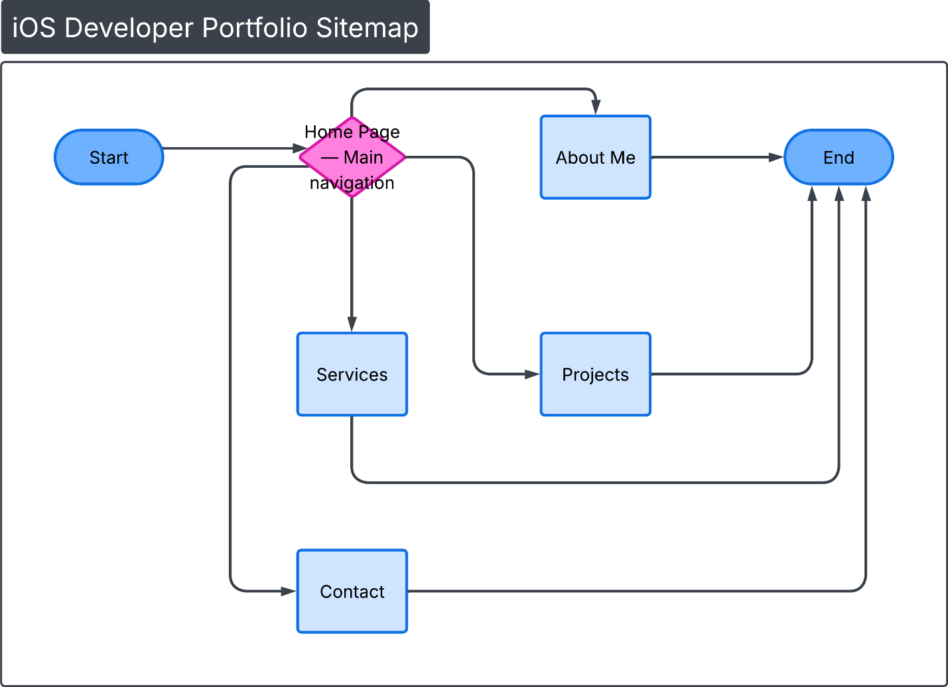
1.3 Target Audience
The target audience for this portfolio website includes several key groups within the technology sector. The primary audience consists of hiring managers and recruiters from technology companies who are actively seeking iOS developers for employment opportunities. These professionals typically look for evidence of technical skills, completed projects, and professional experience when evaluating candidates.
Secondary audiences include potential clients who may wish to hire freelance iOS development services, fellow developers and members of the iOS development community who may be interested in collaboration or networking opportunities, and educators or mentors who may wish to review the portfolio for academic or professional development purposes. Understanding these diverse audience needs has influenced design decisions throughout the development process, ensuring the website communicates relevant information effectively to each group.
1.4 Scope of the Project
The scope of this project encompasses the complete development of a portfolio website, from initial planning through final deployment. The website consists of five distinct pages: a home page providing an introduction and overview, an about page detailing background and experience, a projects page showcasing iOS applications developed, a skills page outlining technical competencies and tools, and a contact page facilitating communication with visitors.
The technical scope includes hand-coding all HTML structures using semantic HTML5 elements, implementing CSS3 for styling and layout including responsive design techniques, incorporating JavaScript for interactive elements and form validation, integrating appropriate graphics and media content, and deploying the completed website to the Netlify platform. This project does not include backend functionality such as database integration or server-side processing, focusing instead on creating a well-designed, static website that effectively presents information to visitors.

CHAPTER 2: PLANNING AND DESIGN
2.1 Content Planning
The content planning phase involved carefully considering what information would be most valuable to the target audience and how to organize it effectively across the five pages of the website. For the home page, I planned to include a welcoming introduction, a professional photograph, and clear navigation to other sections of the site. This page would serve as the first impression for visitors and needed to immediately convey professionalism and competence.
The about page content was planned to provide deeper insight into my background as an iOS developer, including educational qualifications, professional experience, and personal motivation for pursuing iOS development. The projects page required careful curation of portfolio pieces, with each project needing screenshots, descriptions, and technical details about the development process and technologies used.
For the skills page, I organized content into categories including programming languages such as Swift and Objective-C, frameworks and tools such as SwiftUI, UIKit, and Xcode, and additional competencies such as version control with Git and API integration. The contact page was designed to include multiple communication channels including a contact form, email address, and links to professional social media profiles such as LinkedIn and GitHub.
2.2 Design Concept
The overall design concept for the portfolio website draws inspiration from Apple's minimalist design philosophy, which emphasizes clean lines, ample white space, and intuitive navigation. This approach aligns naturally with the content focus on iOS development and creates a cohesive brand identity that resonates with the iOS development community.
The design prioritizes simplicity and clarity, ensuring that content remains the primary focus rather than decorative elements. Navigation is consistent across all pages, with a fixed header containing links to all sections of the site. The layout employs a single-column design on mobile devices and expands to multi-column layouts on larger screens, demonstrating responsive design principles.
As illustrated in Figure 2.1, the wireframe for the home page establishes the basic layout structure that would be implemented in the final design.
[Figure 2.1: Home Page Wireframe]
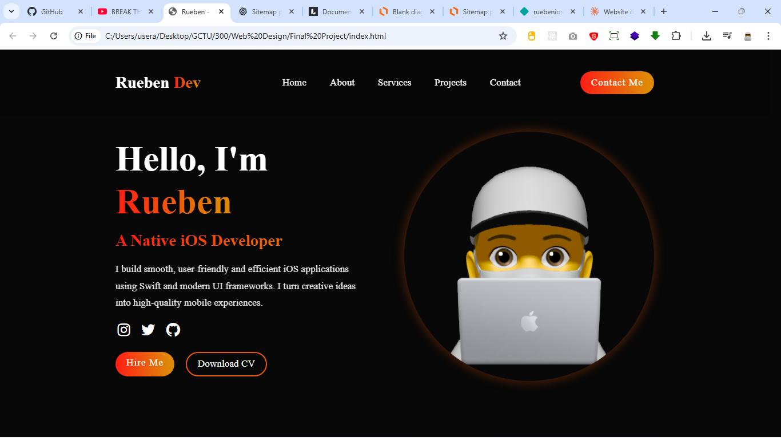
2.3 Site Structure and Navigation
The site structure follows a flat hierarchy with the home page serving as the central hub and four additional pages accessible from any location through consistent navigation. This structure ensures visitors can easily move between sections without becoming disoriented or needing to backtrack through multiple levels.
Navigation is implemented through a horizontal bar positioned at the top of each page, which remains visible as users scroll down the page content. Each navigation item provides clear labeling: Home, About, Services, Projects, and Contact. The current page is visually indicated through highlighting or color change, helping users understand their location within the site.
All pages are properly linked bidirectionally, meaning users can navigate from any page to any other page without restriction. This creates a seamless browsing experience and reduces the number of clicks needed to access desired information. The navigation structure was designed with both desktop and mobile users in mind, with plans to implement a responsive hamburger menu for smaller screens.
CHAPTER 3: WEBSITE DEVELOPMENT
2.4 HTML Structure Development
The HTML structure for the portfolio website was developed using semantic HTML5 elements to create meaningful, accessible, and well-organized code. Each page follows a consistent structural pattern that includes a document type declaration, head section containing metadata and links to external resources, and body section organized into semantic regions.
The basic HTML structure implemented across all pages includes a header element containing the site logo and primary navigation menu, a main element wrapping the primary content of each page, distinct section elements for different content areas within each page, and a footer element containing copyright information and social media links. This semantic approach improves accessibility for screen readers and provides clear document structure for search engines.
As demonstrated in Figure 3.1, the HTML structure diagram shows how elements are nested to create a logical hierarchy that reflects the visual design of the website.

